Arduino Flame Sensor Direction Test

Project Goal
This project tests three flame sensors connected to an Arduino UNO. The system reads flame intensity from LEFT, CENTER, and RIGHT sensors and determines the fire direction.

Sensor Connections
Sensor | Arduino Pin
Left Flame Sensor | A0
Center Flame Sensor | A1
Right Flame Sensor | A2
Relay Placeholder | D7

Threshold Explanation
The flameThreshold value determines when the system decides that a flame exists.
Typical analog readings:
- No flame: 700 to 1023
- Flame detected: 0 to 500
Threshold tuning guide:
300:
- Very strict detection
- Detects only strong or close flames
- Reduces false alarms
- Best for bright environments
500:
- Recommended starting value
- Balanced sensitivity
- Good for normal indoor testing
- Detects medium-distance flames reliably
700:
- Very sensitive detection
- Detects weak or distant flames
- May create false alarms from room lighting or sunlight
- Useful for early testing and calibration

Direction Detection Logic
The Arduino compares all three sensor values. The sensor with the LOWEST reading is considered closest to the flame.

Example
LEFT = 800
CENTER = 320
RIGHT = 760
Result: Fire detected CENTER

Circuit Diagram
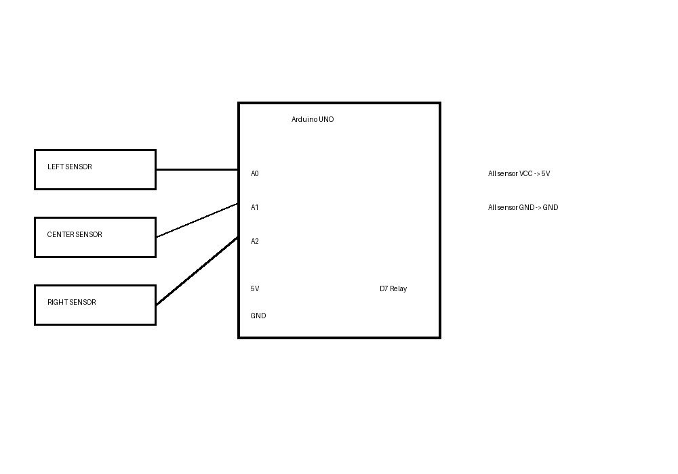

Arduino Source Code
/*
============================================
3 Flame Sensor Direction Test
============================================
Sensors:
Left -> A0
Center -> A1
Right -> A2
Goal:
- Read flame sensor values
- Print values every 500ms
- Detect fire direction:
LEFT / CENTER / RIGHT
- Print:
"No fire detected"
"Fire detected LEFT"
"Fire detected CENTER"
"Fire detected RIGHT"
Future placeholder:
relay_pin = 7 // pump relay (not used yet)
*/
const int leftSensor = A0;
const int centerSensor = A1;
const int rightSensor = A2;
// Future relay for water pump
const int relay_pin = 7; // NOT USED YET
// Flame detection threshold
const int flameThreshold = 500;
void setup()
{
Serial.begin(9600);
pinMode(leftSensor, INPUT);
pinMode(centerSensor, INPUT);
pinMode(rightSensor, INPUT);
// Relay placeholder
pinMode(relay_pin, OUTPUT);
digitalWrite(relay_pin, LOW);
Serial.println("=== Flame Sensor Test Started ===");
}
void loop()
{
// Read sensor values
int leftValue = analogRead(leftSensor);
int centerValue = analogRead(centerSensor);
int rightValue = analogRead(rightSensor);
// Print sensor values
Serial.print("LEFT: ");
Serial.print(leftValue);
Serial.print(" | CENTER: ");
Serial.print(centerValue);
Serial.print(" | RIGHT: ");
Serial.println(rightValue);
// Determine lowest value
// Lower value = stronger flame signal
int minValue = leftValue;
String direction = "LEFT";
if (centerValue < minValue)
{
minValue = centerValue;
direction = "CENTER";
}
if (rightValue < minValue)
{
minValue = rightValue;
direction = "RIGHT";
}
// Check flame threshold
if (minValue < flameThreshold)
{
Serial.print("Fire detected ");
Serial.println(direction);
}
else
{
Serial.println("No fire detected");
}
Serial.println("--------------------------------");
delay(500);
}

